LiR Open House

LiR is for adult learners who enjoy learning in a stimulating and social environment

Remembering G. Fox & Co.
Presented by the Connecticut Historical Society Museum & Library

Friday, February 24, 2023 at 1:00 pm
*Snow date March 3*
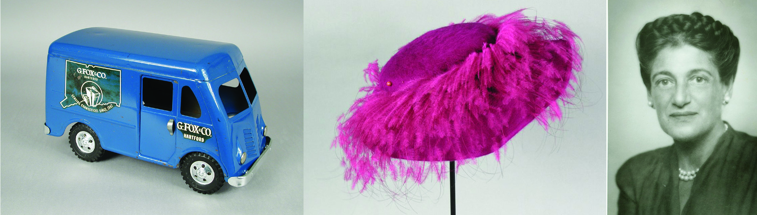

In the 1950s, just about every major city had a landmark department store. In Connecticut, it was G. Fox & Co. in Hartford! This presentation will bring you back in time to Fox’s heyday, as we go from floor to floor and recall the various departments. You’ll also learn about Beatrice Fox Auerbach, the remarkable woman who made every visit to Fox’s special.

Preview Spring Courses ✦ Light Refreshments

NO RESERVATIONS NEEDED

QVCC Auditorium ∙ 742 Upper Maple Street ∙ Danielson, CT ∙ www.qvcc.edu/lir

