Quinebaug Valley Community College

Cultural Programming Committee Presents:

(films of cultural, historic, and artistic significance)

The QVCC Film Series is intended as an instructional experience for all students.

The lecture series is also open to all other curious

high school students, community members, and friendly looky-loos

(***all those interested in learning are welcome***).

A **FREE** showing of the film:

***Thunderheart (1992)***

**(Lead Instructor: Cory McClellan)**

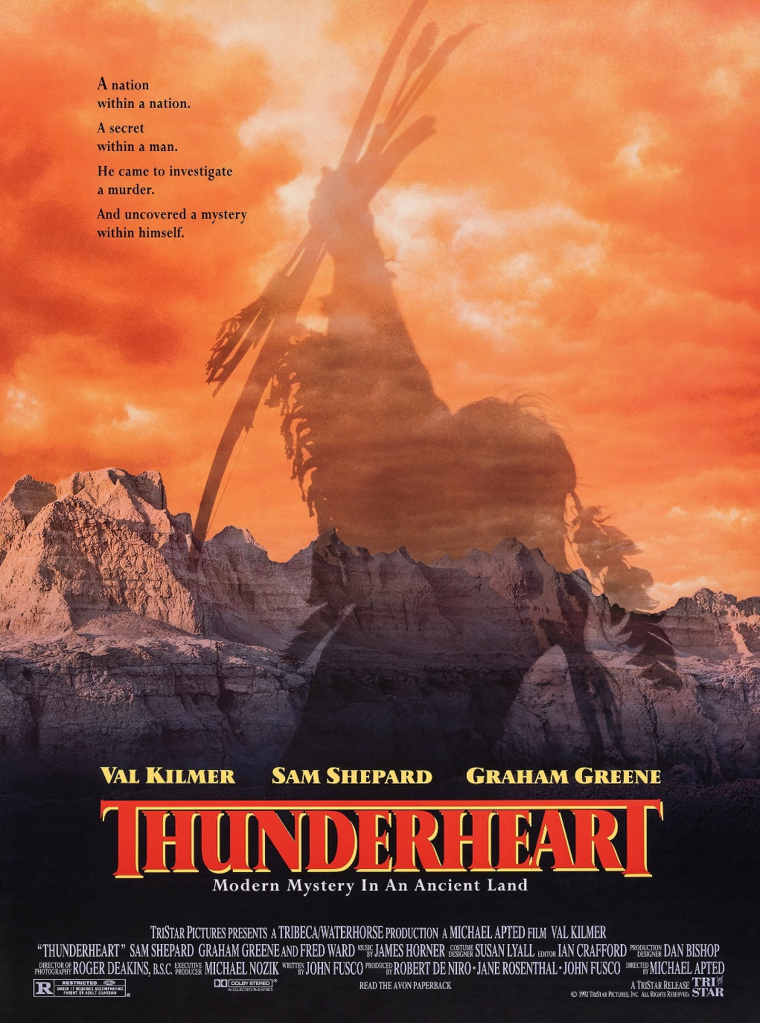

When:

November 16

Where:

QVCC Auditorium

Time:

5:30 pm

**Director:**

**Michael Apted**

**Synopsis:**

**An FBI man with a Sioux background is sent to a reservation to help with a murder investigation, where he has to come to terms with his heritage.**

**Topic of Analysis:**

**How does this 90s neo-Western/Thriller bring consciousness to contemporary Native American societal (and spiritual) concerns?**