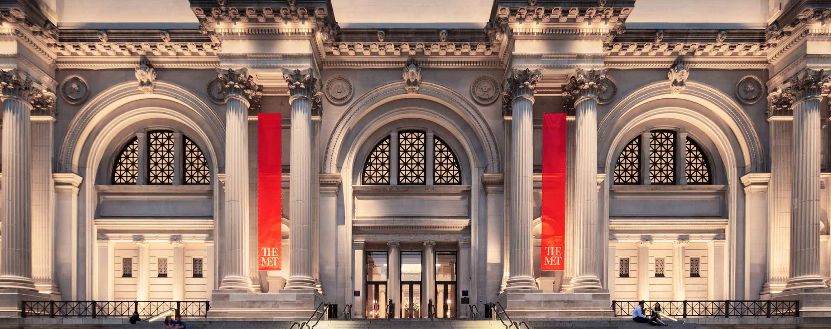  - Friday, November 4  Nyc museum bus trip - met  Take a trip to the Metropolitan Museum of Art  Tickets are on sale at the QVCC bookstore, Windham Tech Library and Winthrop Hall during hours of operation. Students can request transportation from Willimantic to Danielson by contacting Amanda Giles agiles@qvcc.edu. Ticket includes bus transportation and museum admission only.  Questions? Contact Jessica Porzuczek (jporzuczek@qvcc.edu) and Amanda Giles (agiles@qvcc.edu)  Sponsored by QVCC’s: Cultural Programming Committee, Foundation and Student Government Association | Danielson @ 8am  ____  The bus will depart the museum @ 6pm  ____  $10 student  ____  $40 guest  ____  Cash only  Qvcc  742 Upper Maple St.  Danielson, CT 06239  860-932-4020  Qvcc.edu/events

