Student Government Association
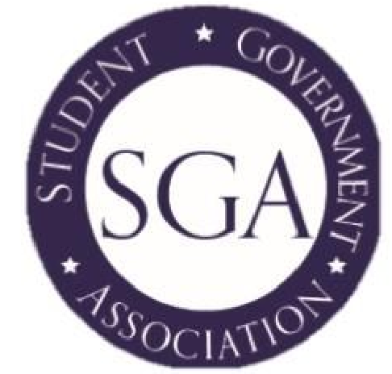
Minutes
September 12, 2017
Start Time: 12:00pm End Time: 12:30pm

Reminders
- Red Sox Game, September 28, 2 tickets left
- 24 Hour Comic, October 6-7
- Panel Discussion, Wednesday, September 13, at 2pm
- Panel Discussion Luncheon, Wednesday, September 13, at 12pm
- Flavors of QVCC: Cookbook Project, recipes due October 1
  - The due date for recipes has changed to gather more recipes

Minutes
Attendees:
- Lukas Warner
- Mark Lowe
- Michaela Grimaldi
- Christina Small
- Heather Vogt
- Roxy Huckaby
- Johnathon Deneault
- Amanda Giles
- Brian Kaufman
- Jayne Battye
Reports:
- SAC – No Report
- Treasurer –
  - $26,000 carry over from last year
  - $61,724 grand total for the year
  - $11,500 approved costs for events
  - $1,450 other approved costs
  - $15,000 for trips, Baugstock, and finals week
  - $6,500 for 12 approved clubs
- Foundation – No Report
Matters of Voting:
- New York City Trip, tentative date is November 10
  - SGA approved $2,125 for the bus trip to New York City. This money will be used to pay for a 55 passenger tour bus to use as transportation to and from New York City.
    - Tickets will cost $15 for students and $20 for faculty, staff, or friends of students. Each person on the bus will need to sign a waiver in order to attend. The bus will depart the Danielson campus at 6am and will make a stop in Willimantic at the old QV center to pick up any Willimantic students who may be interested in attending. Once the bus arrives in New York City, students will have the opportunity to roam and explore the city as they please. Students will need to bring their own money to spend throughout the day. The bus will be leaving New York City at 7pm from the Empire State Building, no one is required to ride the bus back to campus if they have another form of transportation.
- Lunchtime Jams
  - SGA approved $200 for Lunchtime Jams. This money will be used to buy any more cables that they may need for their equipment.
Topics Discussed:
- Open elections will be happening for the open positions
- SGA Bios
  - Christina needs everyone’s information by Friday
- SGA in Willimantic
  - Officers will be going to Windham Tech to interact with students, possibly do a night time food cart, and introduce themselves as SGA members.
- We have a student team coming together for Tackle the Trail
- The registration cost will be covered
Events to be planned:
- Fall Fest
  - Bounce-a-rama, Hay ride from Cedar Knolls, The Big Green Pizza Truck, Jamiliah Henna Creations and Pumpkins are all planned and confirmed to attend.
  - There will be another meeting on Monday, September 18, at noon in the cafeteria.
Items that were Tabled:
- There were no items tabled at this meeting.

The next meeting will be Wednesday, September 20 at 2pm in the Reading Room, W200.

