Student Government Association
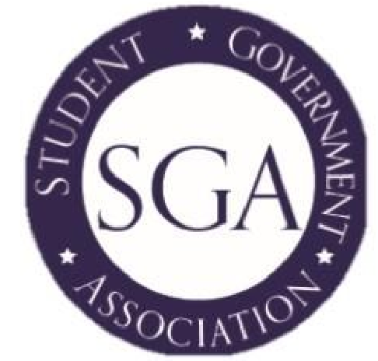
Minutes
Wednesday, August 30, 2017
Start Time: 2:04 PM End Time: 2:55 PM

Reminders
- Pizza with the President, September 6, at noon
- The library is collecting recipes for the Flavors of QVCC: Cookbook Project. The deadline to turn in recipes is September 15.
- President Ojakian is coming on September 19 for a BoR meeting and he will be having lunch with students at 11:30am.
- Red Sox Game on September 28, we have 8 tickets left.

Minutes
Attendees:
- Christina Small
- Roxy Huckaby
- Lukas Warner
- Elle-Jordyn Goslin
- Heather Vogt
- Mykeala Taylor
- Amanda Giles
Matters of Voting:
- Officer Positions
  - SGA approved all officers in their positions
    - Heather Vogt, President
    - Christina Small, Vice President
    - Roxy Huckaby, Representative to the Foundation
    - Micahela Grimaldi, Treasurer
    - Johnathon Deneault, Member at Large
    - Catsy Turre, Member at Large
- Candy for the Learning Center
  - SGA approved $300 for candy for students in the Learning Center.
- Fall Fest
  - SGA approved $5,000 for the budget of Fall Fest. This money will be used to plan the event and pay for any vendors or activities for students to enjoy during this event on October 11.
    - The committee for this event will be meeting on Tuesday, September 6, at noon in the cafeteria and then weekly on Mondays after the first meeting.
- President Ojakian Luncheon
  - SGA approved $250 for a student luncheon with President Ojakian on September 19. This money will pay for the food for students so they have an opportunity to interact with President Ojakian.
- Pizza with the President
  - SGA approved $300 for Pizza with the President. We have 3 dates set for the fall semester: September 6 at Noon, October 18 at 5pm, and November 14 at Noon. This money will pay for pizza for students and should last for the duration of the year.
- Clubs
  - SGA approved $500 per approved club. This money will be given to each established club to pay for any needs of the club.
- Newsletter Mailing Cost
  - SGA approved $100 to pay for the mailing of the semester newsletter to students.
- 24 Hour Comic
  - SGA approved $1000 for the budget to be used to plan 24 Hour Comic. This money will be used to pay for any needs of the event including food for students, supplies, etc. This event will be held October 6-7 from 3pm-3pm.
Topics Discussed:
- Student Surveys
- Roxy reviewed the numbers from the student surveys that were given out at New Student Orientation. These surveys will also be used throughout the semester in order to collect student opinions and feedback for recruitment and student involvement purposes.

Events to be planned:
- Paint Night will be November 9 in the Cafeteria. Christina will be taking charge on this event and will give us more details next meeting.
- SGA and students are interested in a New York City bus trip. Roxy and Amanda discussed the possibility of having the trip during Christmas break and to spend the day in Times Square. More details on this trip will come.
- Six Flags trip for the spring semester will need to begin planning soon. The tentative date will be the end of April sometime.
Items that were Tabled:
- Product ordering was tabled to give everyone more time to look at 4imprint again and talk to Jen Green about what products she has and which we think we should order to have the SGA logo on them.

The next meeting will be Wednesday, September 6 at 2pm in the Reading Room, W200.

